Step 1:
Click right Vivablast Project -> Properties -> Web -> Create Virtual Directory.
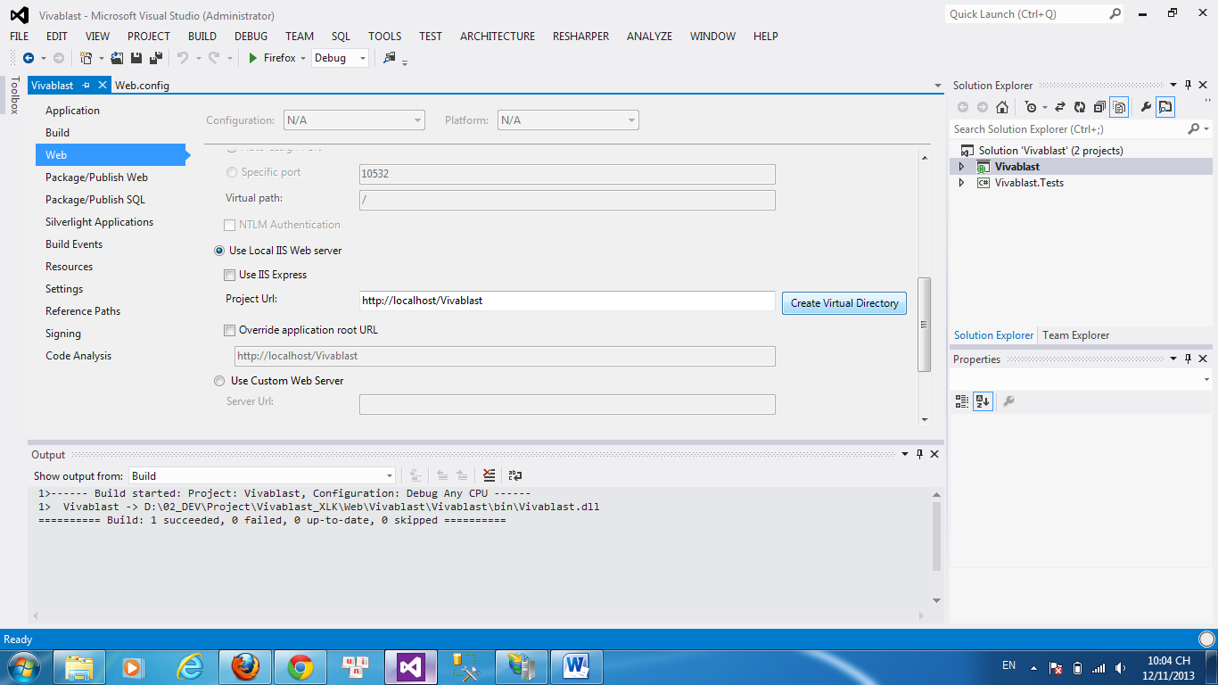
Step 2: Build Solution
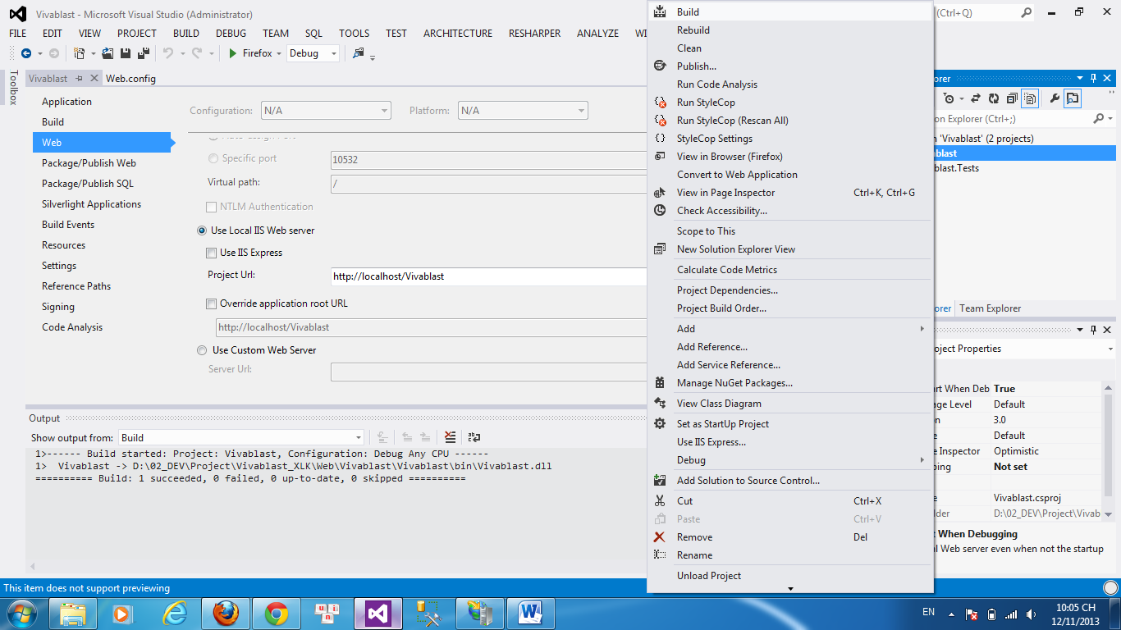
Step 3: My computer. Paste
c:\Windows\Microsoft.NET\Framework\v4.0.30319\aspnet_regiis.exe -i
and Enter -> run to re-register ASP.NET 4.
Step 4: Open IIS Manager and Stop -> Start.
Step 5:
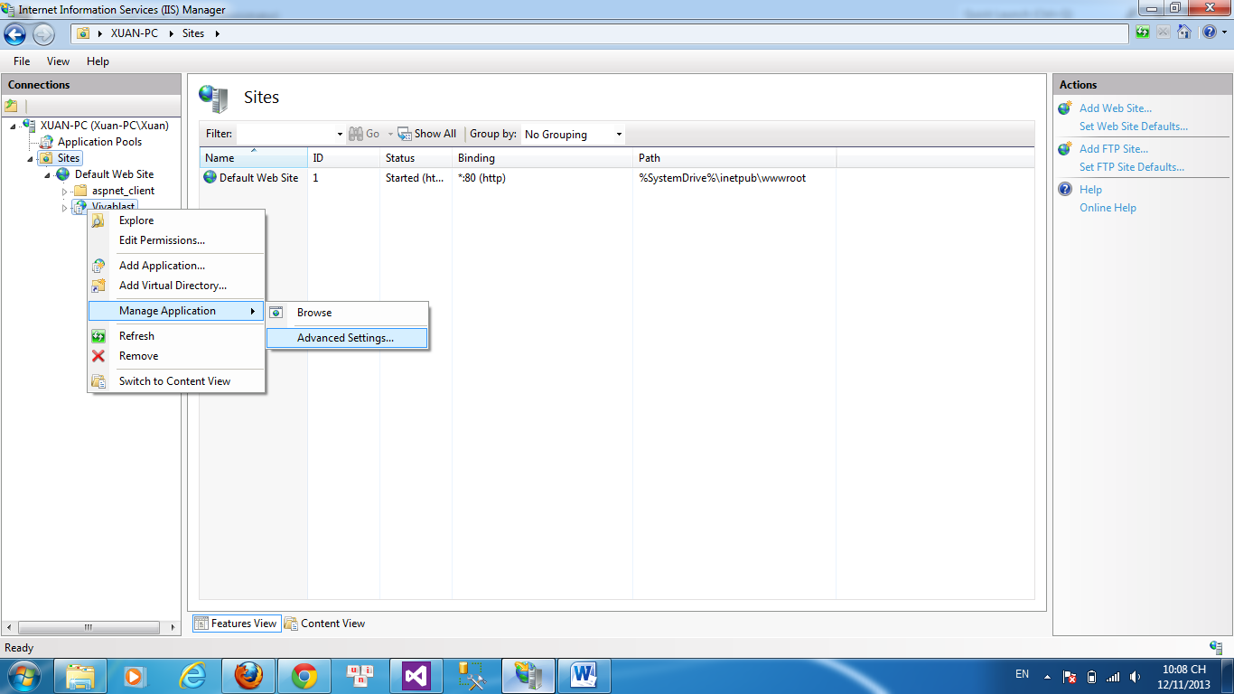
Step 6: Choose as picture:
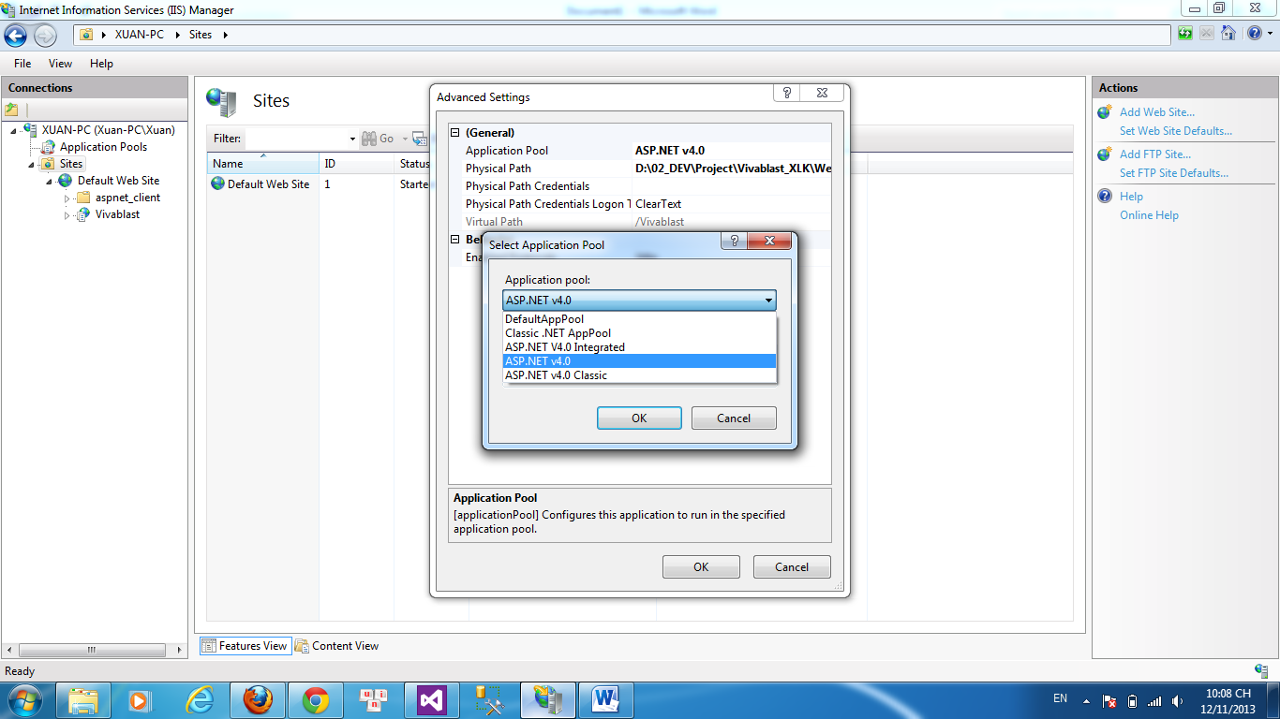
Step 7: Restart IIS
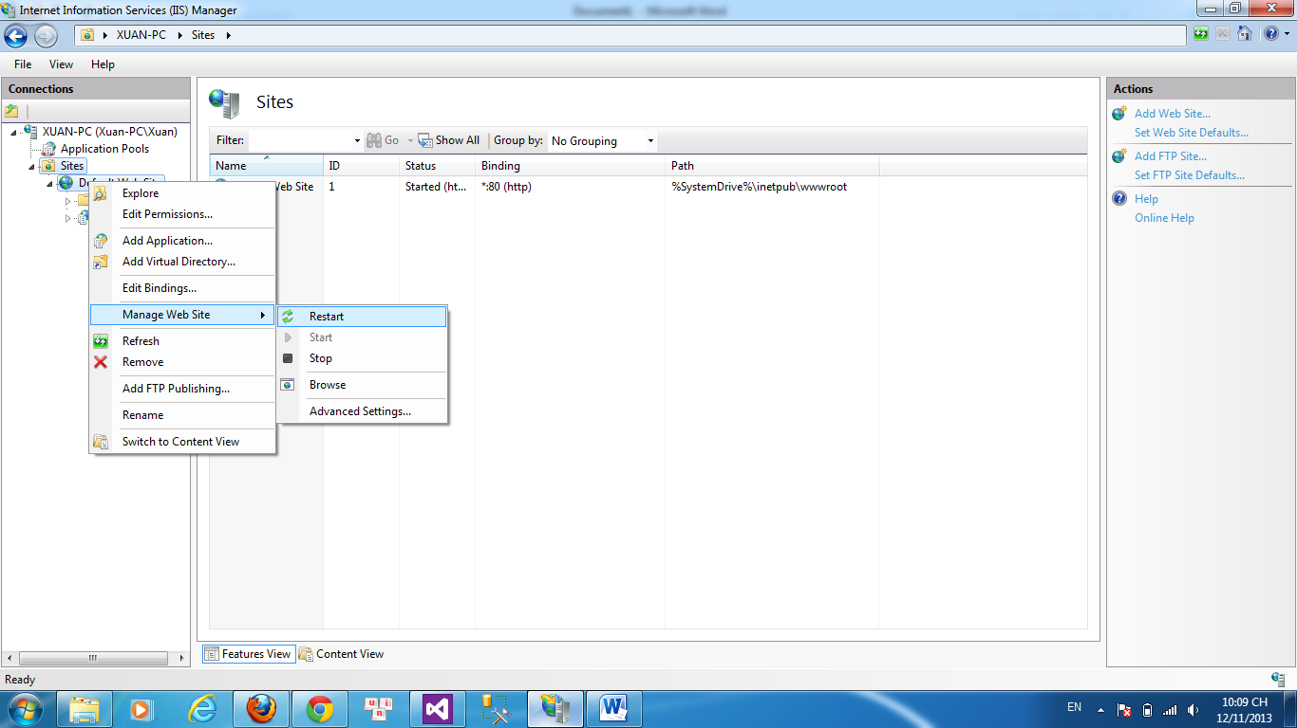
End: browser result
